Why Your Business Needs a NAS and Why FreeNAS is an Excellent Solution
Kyle Willett
Illinois Institute of Technology
Abstract

This paper endeavors to explain to small to medium sized business leader the benefits of consolidated shared storage on a NAS. It explores what a NAS is and how it differs from direct attached storage and storage area networks. It explores the pros and cons of an entry level small business NAS before turning to a case study in the build your own NAS route by examining a high end NAS specific motherboard. The second half of the paper is entirely about the benefits of the FreeNAS operating system and ZFS. The second half explores the benefits of FreeNAS because of its FreeBSD base while at the same time making hardware recommendations where appropriate, particularly when it comes to networking controllers and system memory to use. In the conclusion the paper makes the recommendation that the reader should have a NAS unit in their business and it should be of the build your own variety and run FreeNAS.

Why Your Business Needs a NAS and Why FreeNAS is an Excellent Solution

To say that businesses today deal with a lot of data would be an understatement. Big data is a catch phrase that is tossed around on the evening news. Companies are hiring employees to process this data in record numbers in the new degree fields of data science and data analytics. Forbes says this:
Annual demand for the fast-growing new roles of data scientist, data developers, and data engineers will reach nearly 700,000 openings by 2020. … By 2020, the number of jobs for all US data professionals will increase by 364,000 openings to 2,720,000 according to IBM. (Columbus, 2019)
If one has a company, that company is going to be processing data. Many small companies start off with what is known as direct attach storage (DAS) where computers just try to share their internally connected drives. This works for some really small businesses but as the company grows this method does not scale well. Many companies are finding themselves searching for something more. To get away from DAS a company has two options, a storage attached network or a network attached storage also known as SANs and NASs respectively. While there is a time and a place for a SAN solution most businesses do not necessarily need a SAN and SANs have many disadvantages as well as the price point of a SAN solution put a SAN out of reach and also not the appropriate solution to most businesses that are looking to expand past DAS storage. Enter the NAS, a solution built around NAS addresses the shortcomings of DAS storage solutions and provides many benefits to the business and is also economical to implement as will be shown later. This paper will endeavor to educate the reader on the benefits of a NAS solution compared to a DAS or SAN based solution and introduce one leading NAS platforms FreeNAS and show why it is a superb choice to build a NAS solution around.
A lot of business decision makers may be wondering what a NAS is exactly. Wikipedia, a leading online encyclopedic authority, has this to say:
Network-attached storage (NAS) is a file-level computer data storage server connected to a computer network providing data access to a heterogeneous group of clients. NAS is specialized for serving files either by its hardware, software, or configuration. It is often manufactured as a computer appliance – a purpose-built specialized computer. NAS systems are networked appliances which contain one or more storage drives, often arranged into logical, redundant storage containers or RAID. Network-attached storage removes the responsibility of file serving from other servers on the network. They typically provide access to files using network file sharing protocols such as NFS, SMB, or AFP. From the mid-1990s, NAS devices began gaining popularity as a convenient method of sharing files among multiple computers. Potential benefits of dedicated network-attached storage, compared to general-purpose servers also serving files, include faster data access, easier administration, and simple configuration. (Network-attached storage, 2019)
The textbook Information Storage and Management edited by Somasundaram Gnanasundaram and Alok Shrivastava and authored by many people collectively known as EMC education services has much to say about NAS solutions. They begin by saying that originally floppy disks, then CDs, then DVDs and USB drives were used to transport files around an office setting but as was alluded to in the introductory section this is not sustainable in an enterprise situation where large number of users need access to files (EMC education services, 2012, 157). Next the authors of the text go on to talk about the problems that a NAS solution combats.
Network-based file sharing provides the flexibility to share files over long distances among a large number of users. File servers use client-server technology to enable file sharing over a network. To address the tremendous growth of file data in enterprise environments, organizations have been deploying large number of file servers. These servers are either connected to direct-attached storage (DAS) or storage area network (SAN) - attached storage. This has resulted in the proliferation of islands of over-utilized and under-utilized file servers and storage. In addition, such environments have poor scalability, higher management cost, and greater complexity. Network-attached storage (NAS) emerged as a solution to these challenges. (EMC Education Services, 2012, 157-158)
The authors further explore the benefits of a NAS solution and the benefits it brings to the table for the enterprise consumer:
NAS is a dedicated, high-performance file sharing and storage device. NAS enables its clients to share files over an IP network. NAS provides the advantages of server consolidation by eliminating the need for multiple file servers. It also consolidates the storage used by the clients onto a single system, making it easier to manage the storage. NAS uses network and file-sharing protocols to provide access to the file data. … A NAS device uses its own operating system and integrated hardware and software components to meet specific file-service needs. Its operating system is optimized for file I/O and, therefore, performs file I/O better than a general-purpose server. As a result, a NAS device can serve more clients than general-purpose servers and provide the benefits of server consolidation. (EMC Education Services, 2012, 158)
To summarize the authors, the key benefits of a NAS are as follows: comprehensive access to information, improved efficiency, improved flexibility, centralized storage, simplified management, scalability, high availability, security, low cost, and ease of deployment (EMC Education Services, 2012, 159-160). A NAS device has several key components at the most macro level view it consists of just two things: a NAS head and storage. The NAS head serves as the brains of the operation and the storage consists of the physical media where data is stored. The NAS head itself is made up of a few different components such as the CPU or CPUs and memory, one of more network interface cards or NICs, an optimized operating system build specifically for NAS operations, a file sharing protocol such as NFS or CIFS, a way to connect to disks like a host bus adapter card or HBA or a traditional RAID card or multiple HBAs or RAID cards.
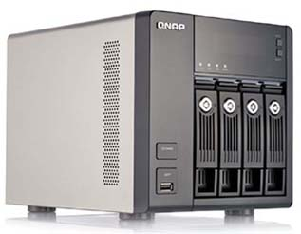
Now that one is familiar with what a NAS is and the benefits one affords to the enterprise one might be saying great how do I get one? There are two main ways to get a NAS solution: 1) purchase a prebuild system like one of the ones described below or 2) build your own. Option one is great for a business that may not have much of a dedicated IT staff or is uncomfortable with designing their own solution. This type of solution looks like this:
Fig. 1
Figure 1 is what is known as a four bay NAS. NAS boxes that come prebuilt are identified by the number of bays that they have. Each bay holds a single SSD or hard disk drive depending on if capacity or speed is wanted to be maximized. More expensive NAS units have more bays to store more data. Also, in general NAS solutions with higher bay counts have faster processors and more memory. The unit in figure 1 is known as the QNAP TS-469 Pro and the review article it was taken from had this to say about the unit:
The TS-469 Pro consists of a four-bay box and an LCD screen that lets you set up, monitor, and manage a basic array configuration. The NAS device packs a 2.13GHz dual-core Intel Atom CPU and 1GB of on-board memory (expandable to 3GB). Ports are plentiful, with one USB 2.0 port on the front and four on the back, and two USB 3.0 ports and two eSATA ports on the back. Network communications are courtesy of a pair of gigabit ethernet ports that support both failover and aggregation, and you can attach a USB Wi-Fi dongle should you wish to use the box wirelessly. In addition to the aforementioned HDMI port, a VGA port lets you hook up older displays … The QNAP TS-469 Pro is a best-of-breed NAS box for small businesses and workgroups, though at $800 it's certainly pricey. (Jacobi, 2013)
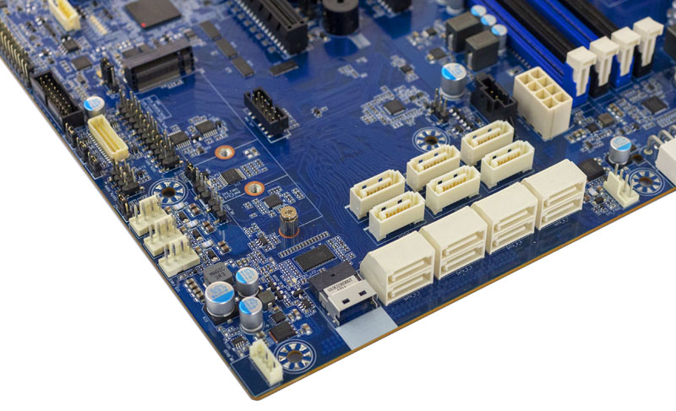
Figure 1 is a good example of what a store bought NAS brings to the table, Four to eight bays for storage devices, a cheap slow atom or ARM processor, one to two GB of memory, and one or two 1GbE network ports for connectivity all for around $1,000. A store bought NAS is not necessarily a bad option, on the contrary it is very desirable for someone with a home office that has maybe just one to three people working in it and needs for only a few TB of shared storage. There is a better option though, a more robust option and that is the build your own NAS. The heart of a custom built NAS is the motherboard and companies like Gigabyte and Supermicro make motherboards specifically for small to medium sized NAS deployments. One website that covers tech gear dedicated to small to medium sized enterprise server gear is serve the home (No idea why it mentions home when it is clearly not gear for a typical household). Serve the Home has a good example of a motherboard that is custom designed for a NAS deployment the late model Gigabyte MB51-PS0. Let’s look at a few features of the Gigabyte MB51-PS0. First see figure 2:
Fig. 2

What we are looking at here is the SATA connectivity of this board. It offers a whopping 14 SATA connectors to support 14 drives without an HBA adapter having to be used. The review article says the connection next to the horizontally mounted SATA connectors is a mini SAS connector for being utilized as a U.2 NVMe connector for a high speed NVMe cache (more on cache later). One can also see an m.2 slot for a single NVMe based SSD for caching purposes as well. Next we turn our attention to figure 3:

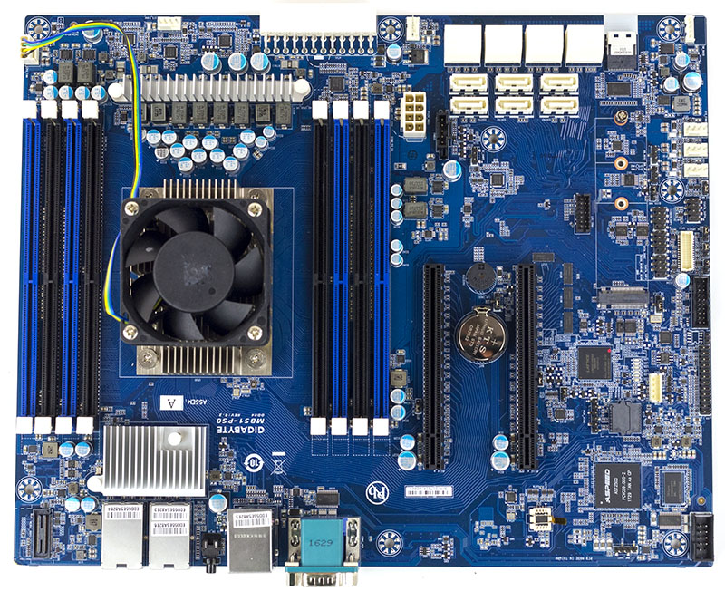
Fig. 3

In figure 3 we see that the MB51-PS0 supports two full length PCIe expansion slots for HBA or RAID cards to increase the number of connected drives beyond the 14 provided by the SATA connections. The review article mentions that electrically the two slots will run at x16 mode without use of the NVMe slots, either the m.2 or the U.2 slot, or if NVMe drives are being used the second expansion slot will run at electrically x8 mode while physically being an x16 slot. We also see the DIMM slots for main memory. There are two quad channels available and the motherboard supports a maximum of “512GB of RAM using 64GB DIMMs” (Kennedy, 2018). Next we turn our attention to the N part of NAS, the network in figure 4.

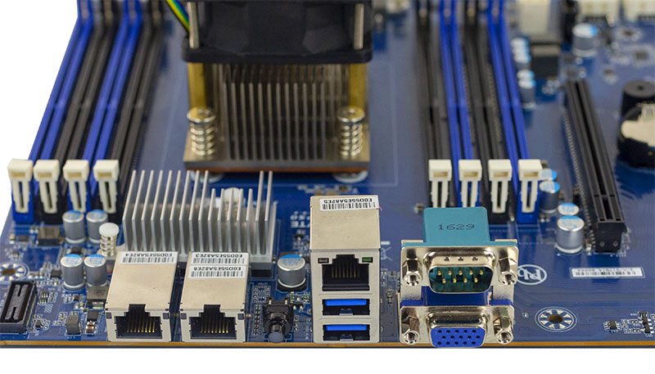
Fig. 4

In figure 4 we first see the network connectivity provided by the MB51-PS0. The MB51-PS0 has not one but two 10GbE copper ports for CAT 6 cabling as well as a port for management over Ethernet. We also see that it has a serial port for connecting to the server over serial connection for management and a VGA port for management, OS installation, or troubleshooting. The final piece of the MB51-PS0 we should talk about is the CPU. Motherboards like the MB51-PS0 use what is known as a SOC or system on a chip and the CPU is a part of the motherboard not separate like on some home or server motherboards and Intel has carved out a little niche developing CPUs specifically for NAS applications. The MB51-PS0 uses the Intel Xeon D-2123IT processor which is a four core process with hyper threading so has eight threads and runs at 2.2 GHz. SOC processors like the Xeon D-2123IT are very energy efficient, this model despite being a robust solution, uses only a maximum of 60 watts. Let’s compare the two solutions we have looked at in each area. First we had an all in one solution that only required the customer to buy drives and run the setup that retailed for around $800. It had 1GbE connectivity but supported two ports for redundancy and a maximum of four drives and had no prevision for SSD cache drives for the hard drives. The build your own option was a much more robust solution. It supported 10 GbE connectivity, 14 native drives, expansion slots for HBA cards for more drives, a much more robust processor as well as supporting half a TB of RAM. Unfortunately, no price point could be found for the MB51-PS0 because it is sold in bulk to organizations needing more than one in their enterprise environment so we can not unfortunately make an apples to apples comparison and include price point but it is possible that the MB51-PS0 could be had for less than a $1,000 but would need RAM and of course drives to be purchased separately. It should be clear to the reader that the build your own solution is better in every single metric possible compared to the prebuilt option. If the enterprise that is considering a NAS has the staff, a custom built approach is the best approach to take using a platform like the MB51-PS0 discussed above. Going custom does have one implication though: the need to provide an operating system for the custom built NAS. This has advantages and disadvantages because on one hand the system administer gets to choose his or her own NAS OS but on the other hand the system administer has to choose his or her own NAS OS. Choosing a NAS OS will be the next topic we discuss.
There are three big leading open source NAS operating systems that compete with one another: open media vault that is Linux based and two FreeBSD based solutions, NAS4Free and FreeNAS. We will be covering FreeNAS in the remainder of this paper. The reader may be wondering why cover FreeNAS over the other open source NAS operating systems and that is a fair point to make. FreeNAS deserves to be the covered operating system because it is the oldest and most stable operating system choice. FreeNAS first came out in October 2005 whereas open media vault came out in 2011 and NAS4Free in March 2012; therefore, FreeNAS has had more time to be developed on than the competitors. FreeNAS out of the leading three NAS operating systems is also the only one with a corporate backing being backed by the company iX systems. It is worth noting that NAS4Free is based on FreeNAS and what can be said about FreeNAS can largely be said about NAS4Free as well since they share a common linage. Without further to do lets introduce FreeNAS:
FreeNAS® is an embedded open source network-attached storage (NAS) operating system based on FreeBSD and released under a 2-clause BSD license. A NAS has an operating system optimized for file storage and sharing. FreeNAS® provides a browser-based, graphical configuration interface. The built-in networking protocols provide storage access to multiple operating systems. A plugin system is provided for extending the built-in features by installing additional software. ("FreeNAS 11.2-RELEASE User Guide", 2018)
The hardware requirements for a FreeNAS box are modest. An AMD64 architecture processor is required; i686 and ARM chips are not supported. 8GB of RAM at the absolute minimum with a more realistic minimum being 16GB (more on memory later) is required. A 8Gb to 16Gb boot device is required with SSDs, USB thumb drives, and SATADOMs (a SATA SSD that gets power from the port) being supported. For networking a wired NIC is required with Intel or Chelsio 1 GbE or 10 GbE Ethernet cards being the recommendation. Realtek networking cards are not recommended and can perform much worse than Intel or Chelsio cards ("Hardware Requirements", 2018) and ("FreeNAS 11.2-RELEASE User Guide", 2018). Next we turn our attention to the so called killer app of FreeNAS, ZFS.
ZFS is a file system developed by Sun Microsystems for their Unix operating system, Solaris, in 2005. It was open sourced along with Solaris in the Open Solaris project. After Sun was acquired by Oracle the operating system was again closed source but the move was politically unpopular leading many engineers at formally Sun and now Oracle to leave and work on the last open source version. That version is now known as OpenZFS. OpenZFS is used by the continuation of the Open Solaris project known as Illuminos as well as other open source Unix operating systems. FreeBSD added support for ZFS in version 7 in 2005 and it has sense become deeply entrenched inside FreeBSD and one of its killer app features. Since FreeNAS is based on FreeBSD it supports ZFS, but it might also make sense to say that because ZFS is in FreeBSD, FreeNAS is based on FreeBSD. There is an entire section of the user guide for FreeNAS dedicated to ZFS. The features will be listed first followed by the implications of the features. ZFS provides: a transactional copy on write file system, a self healing file system, compression, encryption, snapshots, boot environments, write cache, read cache, and built in RAID. Being a Copy on write file system means that:
For each write request, a copy is made of the associated disk blocks and all changes are made to the copy rather than to the original blocks. When the write is complete, all block pointers are changed to point to the new copy. This means that ZFS always writes to free space, most writes are sequential, and old versions of files are not unlinked until a complete new version has been written successfully. ZFS has direct access to disks and bundles multiple read and write requests into transactions. Most filesystems cannot do this, as they only have access to disk blocks. A transaction either completes or fails, meaning there will never be a write-hole and a filesystem checker utility is not necessary. ("FreeNAS 11.2-RELEASE User Guide", 2018)
ZFS is self healing because:
As ZFS writes data, it creates a checksum for each disk block it writes. As ZFS reads data, it validates the checksum for each disk block it reads. Media errors or “bit rot” can cause data to change, and the checksum no longer matches. When ZFS identifies a disk block checksum error on a pool that is mirrored or uses RAIDZ, it replaces the corrupted data with the correct data. ("FreeNAS 11.2-RELEASE User Guide", 2018)
ZFS supports file compression at the block level, not the file level, and ZFS is smart enough to test a file to see if it will benefit from compression before compressing the file, so for example files like JPEGs will not be compressed since they do not benefit from compression. ZFS supports snapshoting which provide low cost backup copies of data due to ZFS being a COW file system. Snapshots initially take up no additional room but increases over time as data is written to that was included in the snapshot. Using the afore mentioned snapshoting technology lets FreeBSD based operating systems like FreeNAS support a feature known as boot environments. With boot environments whenever an operating system update needs to be performed a snapshot of the boot pool is taken and this snapshot is added as a boot option in the boot menu, if the update fails the administrator can simply boot into the last known good configuration by booting the prior snapshot and try to diagnose the problem. ZFS uses a feature known as the ZFS intent log (ZIL) to provide a write cache. This feature can be stored on the hard drives or to provide more performance can be hosted externally on a high speed drive known as a SLOG device. Using a high performance NVMe drive as a SLOG device makes the writing of data appear to be much faster. It is even possible to use a mirrored SLOG device for redundancy incase the SSD was to fail. ZFS uses extra RAM not needed by the operating system functionality as a read cache so that if the same data needs to be fetched multiple times a copy exists in the RAM. This area is known as the ARC. One literally can not have too much RAM in a computer that uses an operating system supporting ZFS because ZFS will use all additional RAM available. In the enterprise setting a tier system can be setup were another high performance SSD device such as another NVMe device can be used as an additional read cache. Such a device is known as a L2ARC. ZFS supports software RAID too known as Z level. RAIDZ1 is the same as RAID 5 and can stand the lose of one drive per pool of storage, RAIDZ2 is the same as RAID 6 and can stand the lose of two drives per pool of storage, and RAIDZ3 can support the loss of 3 drives per pool. Mirroring is also supported just like RAID 1, also a striping mode is supported which is equivalent to RAID 0. Host bus adapters (HBAs) are preferred over traditional RAID cards in a ZFS system. Traditional RAID cards do have on board processors and RAM to do parity calculations and caching which one would think would make them preferable but the processors on RAID cards are simple ARM chips most of the time and the RAM amount is small. ZFS is essentially using the host CPU and RAM as its own RAID card so to say, a much much more powerful RAID card, so while yes the host CPU is being used more for calculations it is also a much more powerful processor than that found on a traditional RAID card. ZFS is also much smarter when it comes to recovery from a drive failure using RAIDZ. On a traditional RAID card when the faulty drive is replaced the copy operating can take hours to days because the card has no way of knowing what blocks were used, ZFS on the other hand only copies the relevant data when resilvering the drives after a hardware failure. As one can see ZFS has many benefits over a traditional file system like ext4, NTFS, XFS, or UFS. ("FreeNAS 11.2-RELEASE User Guide", 2018)
Before moving on we would be remiss if not mentioning RAM. ZFS loves memory. That is a simple fact that must always be remembered. ZFS loves to cache stuff so that reads and writes are faster than a traditional SATA or SAS hard drive can support. When the authors of the user guide say that 8 GB is the absolute minimum they mean that. They say that FreeNAS will not simply perform slower with say 4 GB of RAM, but that it may not perform at all! The conservative estimate for how much RAM one will need is to have, “1GB of RAM per terabyte of disk capacity” ("FreeNAS 11.2-RELEASE User Guide", 2018). If using storage as an iSCSI volume 16GB of RAM is required as an absolute minimum with 32 being the more realistic amount. Jails (more on them later) require 1 to 4 additional gigabytes of memory. Virtual machines require additional memory. A feature of ZFS known as deduplication which is like an advanced compression technology where if multiple copies of the same data are stored the storage amount loss incurred is only equivalent to one copy of the said data requires 5 GB of RAM per terabyte of storage. Memory modules come in two types, the traditional type used in desktop and laptop computers and a type known as ECC memory which stands for error correcting code. ECC memory can correct single bit errors and detect two bit errors in memory. There are a lot of flame wars online in the FreeNAS community forms about rather or not ECC memory is required, and this is because ECC memory costs a significant premium over non ECC traditional memory that can not correct errors. The authors of the user guide have this to say:
If the hardware supports it, install ECC RAM. While more expensive, ECC RAM is highly recommended as it prevents in-flight corruption of data before the error-correcting properties of ZFS come into play, thus providing consistency for the checksumming and parity calculations performed by ZFS. ("FreeNAS 11.2-RELEASE User Guide", 2018)
They summarize the section on ECC memory by boiling the detail down to this fine point, “If your data is important, use ECC RAM” ("FreeNAS 11.2-RELEASE User Guide", 2018). Furthermore, to emphasize the point the authors link to a research paper done by Computer Scientist at the University of Wisconsin that studied how data can get silently corrupted when not using ECC memory and that proves that this is more than just a theoretical concern, that data really can get corrupted when using traditional memory. In summary, when using a ZFS storage pool one should install the absolute maximum amount of memory the budget allows and that memory should be ECC memory. I would also extract from the user guide authors that if one has to choose between more memory but that memory being non ECC or less and it being ECC that it would be preferable to go with less ECC than more non ECC.
Next, we will explore the FreeBSD base of FreeNAS and explain more of why it is a good core of an operating system and strengthens the FreeNAS project. Greg Lehey in the document “Explaining BSD” makes the following argument in favor of FreeBSD:
BSD systems, in particular FreeBSD, can have notably higher performance than Linux. But this is not across the board. … In general, BSD systems have a better reputation for reliability, mainly as a result of the more mature code base. BSD projects have a better reputation for the quality and completeness of their documentation. The various documentation projects aim to provide actively updated documentation, in many languages, and covering all aspects of the system. (Lehey, 2018)
The FreeBSD advocacy project has this to say about FreeBSD security:
Security is vital in any network-connected machine. FreeBSD provides a number of tools for ensuring that you can maintain a secure system, such as: Jails, allowing you to run applications or entire systems in a sandbox that cannot access the rest of the system. With tools like ezjail and ZFS you can instantly create a new jail with a clone of an existing system, using a tiny amount of disk space, and run untrusted code inside it. Mandatory Access Control, from the TrustedBSD project, allowing you to configure access control policies for all operating system resources. Capsicum, from FreeBSD 9 onwards, allows developers to easily implement privilege separation, reducing the impact of compromised code. (Freebsd.org, 2019)
The advocacy group goes on to talk about the other benefits of the operating system that will be listed below. The next point is that FreeBSD is extremely stable, so much so that the marketing team can say this:
Stability means many different things. FreeBSD very rarely crashes (and when it does it is usually due to hardware faults), but while that was a great boast a decade ago, now it is an expected feature for any operating system. Stability in FreeBSD means much more than that. It means that upgrading the system does not require upgrading the user. Configuration interfaces do change over time, but only when there is a good reason. If you learned how to use FreeBSD in 2000, most of your knowledge would still be relevant. Backwards compatibility is very important to the FreeBSD team, and any release in a major release series is expected to be able to run any code—including kernel modules—that ran on an earlier version. The entire base system is developed together, including the kernel, the core utilities, and the configuration system, so upgrades are usually painless. Included tools like mergemaster help update configuration files with little or no manual intervention. (Freebsd.org, 2019)
In Windows and (most) Linux environments (Gentoo Linux is a notable exception) software is installed in binary format using an installer. For example Windows computers install new software with .exe or .msi files and most Linux environments use APT or RPM to install binary software that has been compile to fit a generic x86-64 architecture computer. The BSDs have traditionally used a source based package management infrastructure known as ports. The ports tree is a collection of software install files that can be navigated through on the command line and each directory contains a link to the source file tar ball and a configuration script. The configuration script can apply an almost limitless amount of customizations. Customizations such as lowering the number of attack vectors by turning off network functionality, enabling or disabling specific features inside the application, applying compiler optimization flags to make the program tuned to the particular CPU that the host is running on, and so on. Another perk of well any of the BSD family of operating systems is the ease of customization. All customization can be done from the command line by editing a file called /etc/rc.conf with a text editor. For example only things in this rc file are started up at boot time so for example if one rarely needs to run ssh into the server ssh can be disabled at start up. Last but not least is the networking stack on FreeBSD. FreeBSD has the best networking stack of any operating system bar none. For example the well known company Netflix runs FreeBSD servers exclusively for serving up their content of TV shows and movies. In a world were so many servers run Linux why would this big name company try to run a more obscure OS when there is less skilled talent around supporting it and so on. Simple. The networking stack performs that much better compared to Linux or another operating system. A man by the name of Michael Larabel is the principle writer for the website phoronix.com and lead developer of the phoronix test suite which is the leading benchmarking tool for open source operating systems. He has covered extensively the coverage of Netflix using FreeBSD as a server platform and done testing comparing the network performance of FreeBSD to Windows server and Linux based hosts. Here is what Michael found when testing 10GbE card performance:
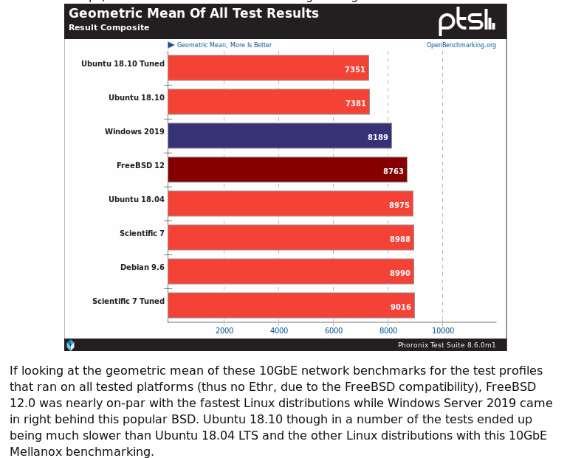
He found that FreeBSD outperformed many Linux distros and Windows server 2019 and that some Linux distros were just slightly faster. Michael is famous or perhaps infamous depending on ones opinion for not optimizing the operating systems when doing benchmarking- he tests the plain vanilla configuration of the operating systems and that is why I would suspect some Linux systems outperformed FreeBSD- because no performance tuning was done on the BSD system. Furthermore, Michael reports that, “With FreeBSD on commodity server hardware they are able to achieve 90 Gb/s serving on TLS-encrypted connections with not even full CPU utilization” (Larabel, 2019). The next key feature shared by both FreeNAS and FreeBSD is a type of light weight virtual machine called a jail. A jail is a way to run software in an isolated environment separate from other software. If jails sounds like a container to the reader it is because it is where the idea for containers came from but has existed long before containers. The FreeBSD handbook, the definitive guide to all things about administering a FreeBSD system, has this to say about jails:
Fig. 5
Jails build upon the chroot (2) concept, which is used to change the root directory of a set of processes. This creates a safe environment, separate from the rest of the system. Processes created in the chrooted environment can not access files or resources outside of it. For that reason, compromising a service running in a chrooted environment should not allow the attacker to compromise the entire system. However, a chroot has several limitations. It is suited to easy tasks which do not require much flexibility or complex, advanced features. Over time, many ways have been found to escape from a chrooted environment, making it a less than ideal solution for securing services. Jails improve on the concept of the traditional chroot environment in several ways. In a traditional chroot environment, processes are only limited in the part of the file system they can access. The rest of the system resources, system users, running processes, and the networking subsystem are shared by the chrooted processes and the processes of the host system. Jails expand this model by virtualizing access to the file system, the set of users, and the networking subsystem. More fine-grained controls are available for tuning the access of a jailed environment. Jails can be considered as a type of operating system-level virtualization. … Jails have their own set of users and their own root account which are limited to the jail environment. The root account of a jail is not allowed to perform operations to the system outside of the associated jail environment. ("Chapter 14. Jails", 2019)
Jails are a powerful feature of a FreeBSD based system that allows tasks segregation for improved security and peace of mind. To conclude this section on FreeBSD it is worth noting that FreeNAS ≠ FreeBSD. They are not one and the same, but that being said most of the things that apply to FreeBSD apply to FreeNAS but there are some caveats. For example, software is typically installed on FreeNAS using a system called plugins and is administered via a web interface for simplicity, but the world of ports and the terminals is available to the user if they so desire to use said tools.
Finally when discussing the world of FreeNAS it is worth noting that FreeNAS despite being an open source specialty operating system has a corporate backing by a company known as iX systems. iX systems develops FreeNAS for the open source community to use as they so desire, but at the same time offers a product called the FreeNAS certified server that are computers that come in 1u, 2u, and 4u configurations and include from 1GbE to 40GbE networking connectivity and support all flash based storage to all hard drive based storage with capacities as low as 48TB for the all flash based array and all the way up to a maximum of 1.85PB with the large hard drive based server. These machines come with FreeNAS already preinstalled on a mirrored flash based storage device ready to be deployed. A solution like this FreeNAS certified server is an attractive option to an enterprise that understands the benefits to a custom approach like was outline above when talking about the Gigabyte MB51-PS0 but is worried about rather or not FreeNAS will support the storage HBAs and NIC devices chosen for the server. So if one has a smaller company and does not want to risk hardware incompatibility and is maybe just getting into the custom built NAS option a FreeNAS certified server solution might be a great middle ground to go with when it comes to a NAS and at the same time a portion of the proceeds generated in the purchase of a FreeNAS certified server goes back to help the developers further improve FreeNAS. This does not contradict the above advice about building ones own server being the best option- it still is the best option and allows for the most customization options, but that being said a FreeNAS certified server strikes a good balance when compared to the extreme of a custom NAS versus a small business prebuilt NAS. The FreeNAS certified Server is such a good choice because it is in essence a custom built NAS with custom high end parts selected just like in the build your own device route, but with the exception of that the part selection has been done by a third party which is in this case is iX systems the chief developer of the operating system that is going to be deployed on the NAS server. ("FreeNAS Certified Servers", 2019)
In conclusion, most enterprises can benefit a great deal by using a special server as a network attached storage device versus using shared folders on servers. A centrally hosted NAS has great benefit to the enterprise. Sometimes the specialty of a SAN device will be needed such as with databases but most of the time a simple NAS will suffice and is therefore sufficient for most business needs. When deciding on what NAS to get a custom built solution with a high end processor and high amounts of ECC memory is desirable much like the Gigabyte MB51-PS0 discussed in this paper, the next best option is a solution like one of the four models of FreeNAS certified server available from iX systems, the least desirable and worst approach is to go with a solution like the QNAP TS-469 Pro discussed in this paper. When building your own NAS, FreeNAS is the superior choice for an operating system to use for many reasons as outline above that include its use of ZFS as the file system used for storage and all the benefits that entails as well as the fact that FreeNAS is built on the legacy, reliability, and firm foundation that is FreeBSD, a Unix that can trace its routes all the way back to AT&T Unix. To sum up the recommendations of this paper in a sentence would be your company needs a NAS, it should be built to spec considering the needs of your company preferably, and it should run FreeNAS as its operating system.
References
Chapter 14. Jails. (2019). Retrieved from https://www.freebsd.org/doc/handbook/jails.html [Accessed 21 Feb. 2019].
Columbus, L. (2019). IBM Predicts Demand For Data Scientists Will Soar 28% By 2020. Retrieved from https://www.forbes.com/sites/louiscolumbus/2017/05/13/ibm-predicts-demand-for-data-scientists-will-soar-28-by-2020/#458019967e3b
EMC Education Services. (2012). Information Storage and Management: Storing ; Managing ; and Protecting Digital Information in Classic ; Virtualized ; and Cloud Environments ; 2nd Edition. John Wiley & Sons.
Freebsd.org. (2019). FreeBSD Advocacy Project. [online] Available at: https://www.freebsd.org/advocacy/whyusefreebsd.html [Accessed 21 Feb. 2019].
FreeNAS 11.2-RELEASE User Guide. (2018, December). Retrieved February 16, 2019, from https://www.ixsystems.com/documentation/freenas/11.2/intro.html
FreeNAS Certified Servers. (2019). Retrieved from https://www.ixsystems.com/freenas-certified-servers/ [Accessed 21 Feb. 2019].
Hardware Requirements. (2018, December). Retrieved February 16, 2019, from https://freenas.org/hardware-requirements/
JACOBI, J. L. (2013). Fast network-attached storage for business and pleasure. PCWorld, 31(10), 119–121. Retrieved from https://ezproxy.gl.iit.edu/login?url=http://search.ebscohost.com/login.aspx?direct=true&db=a9h&AN=90528311&site=ehost-live
Kennedy, P. (2018). Gigabyte MB51-PS0 Review The Big Intel Xeon D Platform. [online] ServeTheHome. Available at: https://www.servethehome.com/gigabyte-mb51-ps0-review-big-intel-xeon-d-platform/ [Accessed 15 Feb. 2019].
Larabel, M. (2019). Netflix Continues Experiencing Great Performance In Using FreeBSD For Their CDN - Phoronix. Retrieved from https://www.phoronix.com/scan.php?page=news_item&px=Netflix-FreeBSD-2019 [Accessed 21 Feb. 2019].
Larabel, M. (2019). Windows Server 2019 vs. Linux vs. FreeBSD Gigabit & 10GbE Networking Performance - Phoronix. [online] Phoronix.com. Available at: https://www.phoronix.com/scan.php?page=article&item=windows-linux-10gbe&num=4 [Accessed 21 Feb. 2019].
Lehey, G. (2018). Explaining BSD. [online] Freebsd.org. Available at: https://www.freebsd.org/doc/en/articles/explaining-bsd/index.html [Accessed 21 Feb. 2019].
Wikipedia contributors. (2019, February 1). Network-attached storage. In Wikipedia, The Free Encyclopedia. Retrieved 03:06, February 13, 2019, from https://en.wikipedia.org/w/index.php?title=Network-attached_storage&oldid=881246896

